Maimuna Alhamid
Participated in the
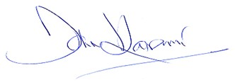
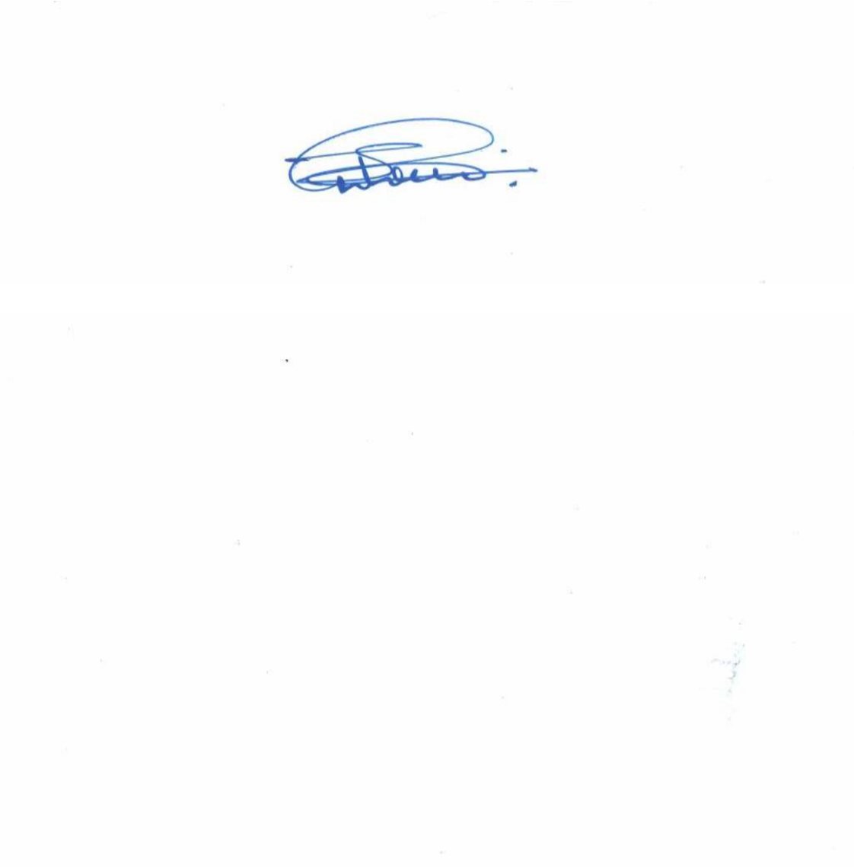




















Kenya Institute of Supplies Management Workshop on
C
P
D
Points
:

30

KISM/CPDW/2023/001433

Council Chairman

Standards Committee

P

A

R

T

I

C

I

P

A

T

I

O

N

This is to certify that

C

E

R

T

I

F

I

C

A

T

E

O

F

A Procurement Training for Committees, CEC’s, User Departments and Procurement Professionals Held on 18th – 22nd September, 2023.
Travellers Beach Hotel & Club, Mombasa.

